**CMPE 273 Lab1**

**Github Repository:**

https://github.com/udaykd09/cmpe273-lab1

**Browser Screenshot:**

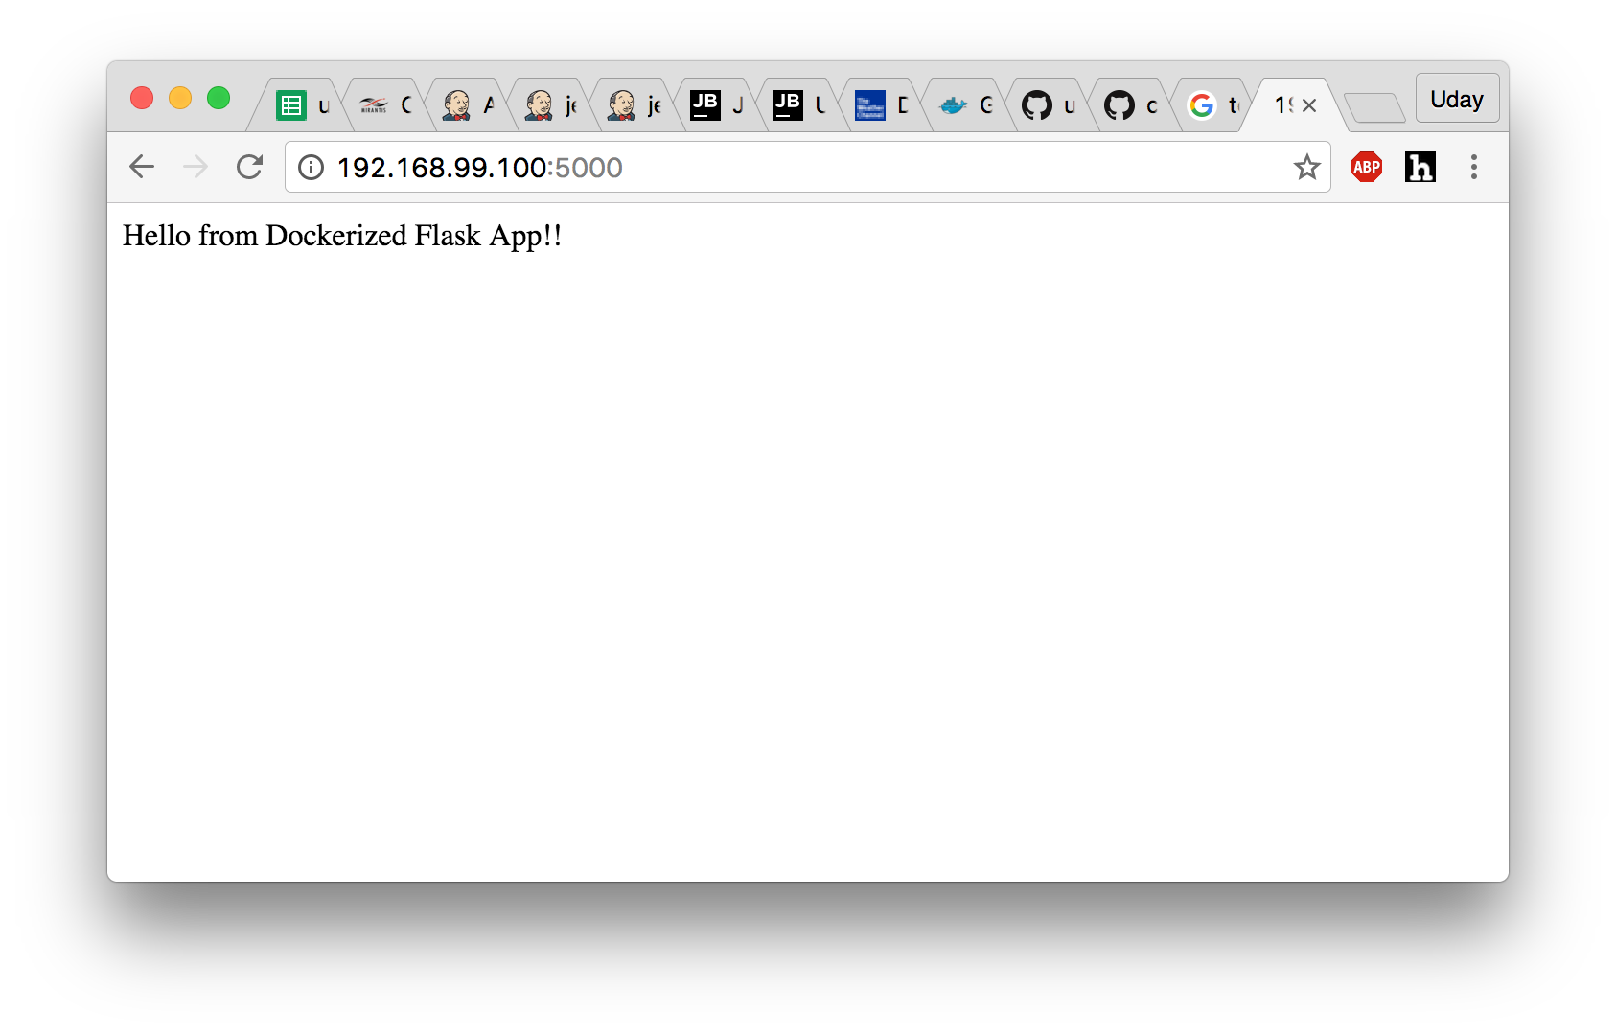

**CLI Output:**

uday-macbook-pro:cmpe273-lab1 uday$ eval "$(docker-machine env default)"

uday-macbook-pro:cmpe273-lab1 uday$ docker images

REPOSITORY TAG IMAGE ID CREATED SIZE

uday-macbook-pro:cmpe273-lab1 uday$ ls -ltr

total 32

-rwxrwxrwx 1 uday staff 14 Aug 31 21:51 README.md

-rwxrwxrwx 1 uday staff 6 Aug 31 21:54 requirements.txt

-rwxrwxrwx 1 uday staff 191 Aug 31 21:55 app.py

-rwxrwxrwx 1 uday staff 158 Aug 31 21:55 Dockerfile

uday-macbook-pro:cmpe273-lab1 uday$ docker build -t lab1-flask-app:latest .

Sending build context to Docker daemon 51.2 kB

Step 1 : FROM python:3.5.2

3.5.2: Pulling from library/python

357ea8c3d80b: Pull complete

52befadefd24: Pull complete

3c0732d5313c: Pull complete

855820c72656: Pull complete

ef2c3e4d30a0: Pull complete

7dcfe1c4947f: Pull complete

44e378b46803: Pull complete

Digest: sha256:f8788eff91ce813a69c0038865e5334c83e3ac9ad69a92c90a762fe178bfdf91

Status: Downloaded newer image for python:3.5.2

---> a494acfeb166

Step 2 : MAINTAINER Your Name "udaykd09@gmail.com"

---> Running in 26cdb38d575d

---> e994f2b87a04

Removing intermediate container 26cdb38d575d

Step 3 : COPY . /app

---> 405cd876267d

Removing intermediate container e8c8e521e4ca

Step 4 : WORKDIR /app

---> Running in 17d692e542db

---> b044b7f94ce5

Removing intermediate container 17d692e542db

Step 5 : RUN pip install -r requirements.txt

---> Running in eac718bfc558

Collecting flask (from -r requirements.txt (line 1))

Downloading Flask-0.11.1-py2.py3-none-any.whl (80kB)

Collecting itsdangerous>=0.21 (from flask->-r requirements.txt (line 1))

Downloading itsdangerous-0.24.tar.gz (46kB)

Collecting click>=2.0 (from flask->-r requirements.txt (line 1))

Downloading click-6.6.tar.gz (283kB)

Collecting Jinja2>=2.4 (from flask->-r requirements.txt (line 1))

Downloading Jinja2-2.8-py2.py3-none-any.whl (263kB)

Collecting Werkzeug>=0.7 (from flask->-r requirements.txt (line 1))

Downloading Werkzeug-0.11.11-py2.py3-none-any.whl (306kB)

Collecting MarkupSafe (from Jinja2>=2.4->flask->-r requirements.txt (line 1))

Downloading MarkupSafe-0.23.tar.gz

Installing collected packages: itsdangerous, click, MarkupSafe, Jinja2, Werkzeug, flask

Running setup.py install for itsdangerous: started

Running setup.py install for itsdangerous: finished with status 'done'

Running setup.py install for click: started

Running setup.py install for click: finished with status 'done'

Running setup.py install for MarkupSafe: started

Running setup.py install for MarkupSafe: finished with status 'done'

Successfully installed Jinja2-2.8 MarkupSafe-0.23 Werkzeug-0.11.11 click-6.6 flask-0.11.1 itsdangerous-0.24

---> 61b518fc9e14

Removing intermediate container eac718bfc558

Step 6 : ENTRYPOINT python

---> Running in 77ac671f4d3b

---> c38bda1a1e68

Removing intermediate container 77ac671f4d3b

Step 7 : CMD app.py

---> Running in 50224e99dcc5

---> 33b41681d95f

Removing intermediate container 50224e99dcc5

Successfully built 33b41681d95f

uday-macbook-pro:cmpe273-lab1 uday$ docker images

REPOSITORY TAG IMAGE ID CREATED SIZE

lab1-flask-app latest 33b41681d95f 23 seconds ago 695.8 MB

python 3.5.2 a494acfeb166 5 days ago 685.3 MB

uday-macbook-pro:cmpe273-lab1 uday$ docker run -d -p 5000:5000 lab1-flask-app

c2bfcbd38758ca3f47703bb1672d3c37908685e4a8e1097d398d7ba72b04e732

uday-macbook-pro:cmpe273-lab1 uday$ docker-machine ls

NAME ACTIVE DRIVER STATE URL SWARM DOCKER ERRORS

default * virtualbox Running tcp://192.168.99.100:2376 v1.12.1